THE EFFECT OF STATE OWNERSHIP ON CASH-FIRM VALUE RELATIONSHIP WITH BAYESIAN APPROACH
Phan Huy Tam – University of Economics and Law, VNU-HCM – tamph18704@sdh.uel.edu.vn (corresponding author)
Nghiem Phuc Hieu – University of Economics and Law, VNU-HCM
Pham Chi Khoa - University of Economics and Law, VNU-HCM
Nguyen Van Tan - University of Economics and Law, VNU-HCM
Pham Thi Kim Anh - University of Economics and Law, VNU-HCM
Nguyen Huong Tra - University of Economics and Law, VNU-HCM
HCMC, July - 2019
ABSTRACT
This study examines the effect of state ownership level on the relationship between cash holding ratio and firm’s value of 39 companies in Retail and Food & Beverage industries which are listed on Vietnam stock exchange market. Since the growing debate on the p-value’s validity of classical frequentist statistic approach, this paper applies the Bayesian approach by using BayesFactor package in R software. In general, the results indicate the positive impact of cash on firm’s value. However, inverted U-Shape relationship between cash holding and firm’s value is not completely supported. Besides, the results of this study reflect that specifically in Vietnam, the enterprises with state ownership are highly valued. Finally, this study concludes that cash could contribute more to the firm’s value with lower state ownership and vice versa. This research recommend that enterprise could consider adjusting the cash holding ratio according to their state ownership ratio in order to maximize the positive effect of cash into firm value.
Keywords: Bayesian, Cash, Firm Value, State Ownership, Vietnam.

INTRODUCTION
In the recent years there has been a growing interest in corporate cash holdings in the finance literature and many financial theories support this point. Free cash flow theory suggests that managers have the intention to hold cash to serve their own interests, thus increase the conflict between investors and company’s managers (1, 2). The theory of free cash flow also highlights the representative cost and benefit of holding cash. Firms with high growth opportunities often face high agency costs, and they also keep higher cash amount to be maintain active position in their capital. This results higher conflicts between managers and shareholders.
The subject on the relationship between cash holding and firm’s value is still being debated based on empirical theory and evidence, creating many different perspectives. Some recent studies support the existence of a positive relationship between firm value and the cash holding ratio (1, 7). In contrast, some other researchers suggest that keeping more cash will reduce the performance or value of the companies (8-10). Moreover, the third view believes in a nonlinear relationship between cash holding and firm’s performance or value. However, these papers also state the strong effect of cash holding ratio on firm’s value (11-13).
In addition, state ownership might have a negative effect on the management efficiency of the firms, but also generates positive impact on firm’s value by some exclusive rights that come along with the state ownership, many previous studies across countries confirm the positive relationship between state ownership and firm performance as well as firm’s value (14-19). Furthermore, the state ownership also impacts on the cash holding level as well other factors such as leverage policy, profitability and dividend policy and others (20).
Consequently, the main aim of this paper is to examine the effect of state ownership on the relationship between cash holding and firm’s value. The authors represent the interaction term between state ownership and cash holding in the regression model of firm’s value. Besides, as the growing debate on the p-value’s validity of classical frequentist statistic approach, this paper applies the Bayesian approach by using BayesFactor package in R software. To the best of the authors’ knowledge, this is the first study about the effect of the interaction between state ownership and cash holding ratio on firm’s value with the Bayesian approach.
The paper includes five parts: Section 1: introduces research issues; Section 2: presents literature reviews and hypothesis; Section 3: presents data collection and methods; Section 4: presents the results of empirical research; the final section summarizes the findings and implications.
LITERATURE REVIEW
Besides, the peaking order theory of Myers and Majluf (3) suggests that managers can decide the order of capital financing to minimize the cost of information asymmetry. Myers and Majluf (3) believe that the safest securities should be issued first and still the authors argue that holding cash should serve as a buffer between retaining profits and investment needs.
In addition, the trade-off theory (4) suggests that companies can choose between options of borrowing or retaining cash, and no matter how, they all have their advantages and costs. The company can determine a level of cash holdings by balancing the marginal cost of holding highly liquid assets and the profit margins of holding cash. Furthermore, the motives of holding cash by Keynes (5) and (6) also explain the impact of cash management on firm’s performance or value.
Lee & Powell (7) examine the determinants of corporate cash holdings in Australia and the impact on shareholder wealth of holding excess cash. They conclude that the trade‐off model best explains the level of a firm’s cash holdings in Australia, and the marginal value of cash also declines with larger cash balances, and the longer firms hold on to excess cash. Besides, Martinez-Solano (11) studied the effect of cash holding ratio on firm value at US market and found that the existence of the optimal cash level which could help the firms to maximize their values and deviate from this optimal cash level will reduce the firm value.
The paper of Saddour (8), investigates the determinants of the cash holdings of French firms over the period 1998- 2002, using the trade-off theory and the pecking order theory. This paper showed that the effect of cash holding level on firm value (which is measured by Tobin-Q) depend on risk tolerance, growth rate, size, level of liquid assets and short-term debt.
Harford (9) studied the relationship between corporate governance level and the excess cash for the sample of the US market. This paper stated that the combination of excess cash and weak shareholder rights leads to increases in capital expenditures and acquisitions. Firms with low shareholder rights and excess cash have lower profitability and valuations. However, there is only limited evidence that the presence of excess cash alters the overall relation between governance and profitability.
Shinada (13) uses panel data from Japanese listed firms during 1980-2010 to analyze the factors that influence firms' cash holdings and determine whether cash holdings are related to corporate performance and values. The restults implied that under a sudden deterioration in the economy, conservative cash holdings could temporarily increase firms' market values, but, in the long run, a highly conservative liquidity management policy would weaken firms' profitability on assets.
In Vietnam, the research of Ha (12) uses the sample of 650 firms over the period 2008 – 2015 to examine the effect of cash holding ratio on firm value. This study supports the inverted U-Shape in the relationship between cash holding ratio and firm value. Besides, the results also claim that there is a statistically insignificant positive relationship between state ownership and firm value unless the state ownership’s advantages are utilized
METHODOLOGY
Data
This study uses secondary data from annually audited financial statements of firms in Retail and Food & Beverage industries in both Ho Chi Minh and Hanoi markets which can be collected from the website: https://vietstock.vn/. The Vietnamese Retail sector is projected to register strong double-digit growth during the forecast period, 2019 to 2024. Especially, Food & Beverage sector is considered among the remarkably rising sectors in Vietnam thanks to its 94-million-population emerging market and its fast GDP growth for years. Both has demonstrated strong growth in the new Vietnam’s face. The information about state ownership is tracked down annually, any changes in proportion of state ownership are recorded and include in the test dataset. The test period is 5 years from 2014 to 2018, any company that does not satisfy the data time length available will be excluded. With this sampling method, data collected includes 39 companies which results in 195 observations.

Variables
This study use Tobin’s Q as proxy for firm’s value which is the dependent variable in the model. According to Lewellen and Badrinath (21), Tobin’s Q is the ratio of the firm’s market value to the replacement cost of its assets which can be calculated by dividing the market value of firm’s equity to the book value of firm’s equity. Tobin´s Q is commonly used among many recent studies to measure firm performance and valuation (22-25).
The key independent variable in this paper is cash holding ratio, measured as cash and cash equivalent to total assets. According to Martínez-Sola, García-Teruel (11), the optimal level of cash holding largely depends on cash and its square with other control variables to affect firm’s value. Besides, some recent papers confirm the inverted U-shape relationship between cash holding and firm’s value in Vietnam market (12). So, this study includes both cash and cash square in the model to serve the test for existence of a non-linear relationship.
As the main objective of this paper is to investigate the effect of state ownership on the relationship between cash holding and firm’s value, the model includes soe variable measured as the percentage of state ownership in the company’s equity structure. According to the scatter plot of soe to Tobin’s Q as shown in The Figure 1, soe is defined as a categorical variable which is categorized into 4 levels of 0-10%, 10%-30%, 30%-50% and above 50% of state ownership to total equity. Furthermore, according to Megginson, Ullah (20) the state ownership has an effect on the cash holding level of the firm, then the authors introduce an interaction term between state ownership and cash holding ratio (cash:soe).

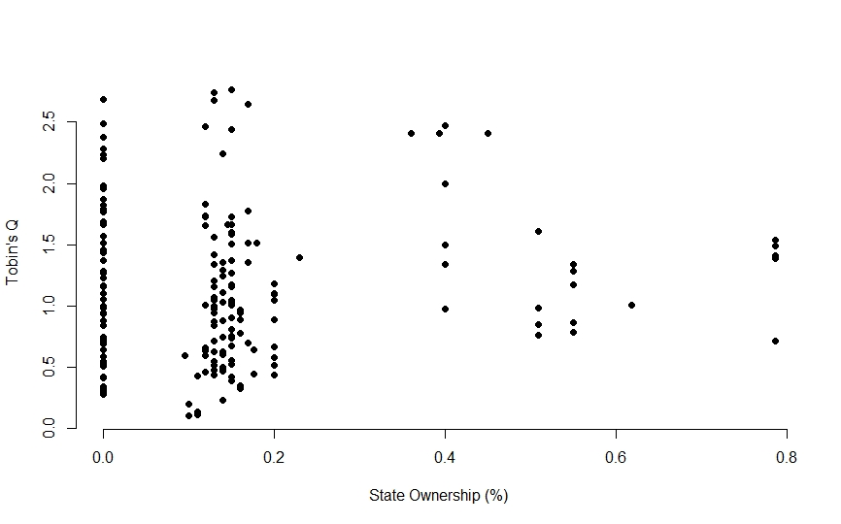

Figure 1: Scatter plot of State Ownership on Tobin's Q
According to McConnell and Servaes (26) and Morck, Shleifer (25), growth, size, profitability and leverage are considered as important determinants of Tobin´s Q. These three control variables are also included to the test. The model used is presented in the equation below:
Tobin’s Q (V_{it}) = β₀ + β₁(Cash_{it}) + β₂(Cash_{it}²) + β₃(Growth_{it}) + β₄(Size_{it}) + β₅(Prof_{it}) + β₆(Lev_{it}) + β₇(SOE_{it}) + Cash:SOE + ε_{it}
Where:
- i is the accumulation of firms; t is time;
- V_{it} is the Tobin’s Q representing the firm value;
- Cash_{it} and Cash_{it}² are cash holding ratio and its square;
- Growth_{it} represents for corporate growth;
- Size_{it} represents for corporate size;
- Prof_{it} represents for corporate profitability;
- Lev_{it} represents for corporate leverage;
- SOE_{it} is the percentage of state ownership of the firm;
- Cash:SOE is the interaction term between Cash and SOE;
- β₀ to β₇ are coefficients;
- ε_{it} is the errors.
Following the method of Martínez-Sola, García-Teruel (11), growth is measured by natural logarithm of growth of total assets, if total the change in total asset is not positive, this will take value of zero; size is measured by natural logarithm of gross sales; profitability is measured by net profit plus depreciation divided by total assets; and leverage is measured by total debt divided by total assets.
Frequentist vs Bayesian approach
The Bayesian vs Frequentist debate is one of the most attracted academic arguments nowadays. This study focuses in applied Bayesian linear modeling. This section will attempt to introduce the concept of Bayesian linear regression by briefing review of the frequentist approach to linear regression and then introduce the Bayesian interpretation to demonstrate the main differences between these two approaches.
The frequentist linear regression model assumes that the response variable is a linear combination of weights multiplied by a set of predictor variables. The full formula also includes an error term to account for random sampling noise.
Y = β₀ + β_{1*}X₁ + β₂*X₂ + … + β_{n}*X_{n} + ε
- Y is the response variable (also called the dependent variable)
- β₁ … β_{n} are the weights (known as the model parameters)
- X₁ … X_{n} are the values of the predictor variables,
- ε is an error term representing random sampling noise or the effect of variables not included in the model
The main objective of doing frequentist linear regression model is to obtain the coefficients from the dataset, that minimize the residual sum of squares. This is known as the maximum likelihood estimate of the coefficients because it is the value that is the most probable given the inputs and outputs. This method of fitting the model parameters by minimizing the residual sum of squares is called Ordinary Least Squares.
Thus, single estimate for the model parameters based only on the dataset is the result of frequentist linear regression. This way, the model is completely depended on the data. From this point of view, all information that researchers need to build a model is already encoded in the data available. However, in case of data restriction, small sample might cause bias problem since the dataset is not big enough to obtain all information which required to form a reliable model. This is where Bayesian linear regression comes in.
In the Bayesian viewpoint, the linear regression is formed by using probability distributions rather than point estimates. The response is not estimated as a single value but is assumed to be drawn from a probability distribution. The aim of Bayesian Linear Regression is not to find the single “best” value of the model parameters, but rather to determine the posterior distribution for the model parameters. Not only the response generated from a probability distribution, but the model parameters are assumed to come from a distribution as well. This is a simple expression of Bayes Theorem, the fundamental underpinning of Bayesian Inference:
$$Posterior=\frac{Likelihood * Prior}{Normalization}$$
- Likelihood: simply the information from the dataset
- Priors: domain knowledge, or a guess for what the model parameters should be. Unlike frequentist approach which assumes everything about the parameters comes from the data. If not specified, use normal distribution.
- Posterior: a distribution of possible model parameters based on the data and the prior, fewer data points, the posterior distribution will be more spread out.
As the amount of data points increases, the likelihood washes out the prior, and in the case of infinite data, the outputs for the parameters converge to the values obtained from OLS. In practice, evaluating the posterior distribution for the model parameters is intractable for continuous variables, so Bayesian approach use sampling methods to draw samples from the posterior in order to approximate the posterior. The most common algorithm is Markov Chain Monte Carlo. This study also uses this method for sampling posteriors of model parameters.
In this study, data interpreting and testing follow the procedure with 4 steps as below:
- All required data are extracted and calculated from raw input data (financial statements). Outliners are replaced with the closest values.
- Using available function of BayesFactor library (27) in R software to perform model selection.
- Apply Markov Chain Monte Carlo (MCMC) algorithm draw samples from the posterior distribution for the model parameters, using 10,000 steps of MCMC algorithm.
- Discuss on results on make conclusion.
RESULTS
Descriptive statistics from Table 1 shows that the Tobin’s Q value for firms in the sample range from 0.1 to 2.76 with the mean of 1.15. The average cash holding ratio is about 13% while the total sample fluctuates from 0.03% to 39.6%. Among other control variables, there are some notable values such as highest leverage is 94.3%, min of prof is negative since companies experienced loss in some cases, and min of growth is 0 if the change in total asset is not positive, the value will be replaced by zero as mentioned above. For soe variable, Figure 1 shows that except of zero state ownership, the government own from 15% to 20% of most firms in the sample, these values are then transformed into categorical variable with 4 levels as described above.
Table 1: Descriptive Statistics of variables
Variables | Min | 1st Quantile | Median | Mean | 3rd Quantile | Max
tobinq | 0.10470 | 0.63960 | 1.01100 | 1.15310 | 1.51480 | 2.76750
cash | 0.00037 | 0.04608 | 0.09084 | 0.13158 | 0.18769 | 0.39651
cash2 | 0.00000 | 0.00212 | 0.00825 | 0.02415 | 0.03523 | 0.08865
lev | 0.04507 | 0.29986 | 0.45699 | 0.44847 | 0.60257 | 0.94388
size | 9.733 | 12.798 | 13.876 | 13.903 | 14.977 | 17.778
prof | (0.09705) | 0.15953 | 0.25203 | 0.31619 | 0.41285 | 0.81507
growth | 0.00000 | 0.00000 | 10.07000 | 8.04000 | 11.70000 | 16.75000
Source: Authors calculate from raw data in R
From the base model as mentioned above which include all variables, generalTestBF function of BayesFactor package will try to score all models formed by all possible combinations from available variables. The test result includes 159 possible models with all available variables. The Figure 2 shows the change in Bayes Factor when omitted variables from most complex model which includes all variables. Profitability has a highest number with more than 100, following by interaction term cash:soe. Besides, cash, size, and soe variables also have strong effect, and growth has least positive number. In contrast, lev causes the decrease when included in the model, cash2 also shows a very weak negative effect on the model score.
Table 2: Five best models from all variables accordance to Bayes Factor score
No. | Model | Bayes Factor Score
1 | cash + size + growth + prof + soe + cash:soe | 9765.68 | ±0%
2 | cash + cash2 + size + growth + prof + soe + cash:soe | 8967.50 | ±0%
3 | cash + size + prof + soe + cash:soe | 7947.89 | ±0.01%
4 | cash + cash2 + size + prof + soe + cash:soe | 5436.88 | ±0%
5 | size + prof | 3706.28 | ±0%
Source: Authors calculate by generalBF function of BayesFactor package in R
Five best models with highest Bayes Factor score are represented in the Table 2, as expected, all five best models do not include leverage since this variable reduce the model score. All of these five models have very high Bayes Factor scores but only model 2 and model 4 retain the key variables which is cash2 (square of cash holding ratio). As the result of Figure 2, the negative effect of cash2 on model score is very weak. Accordance to the study objective, authors will try to keep cash2 in the model to test the nonlinear relationship, then model 2 and model 4 with variable cash2 is selected.

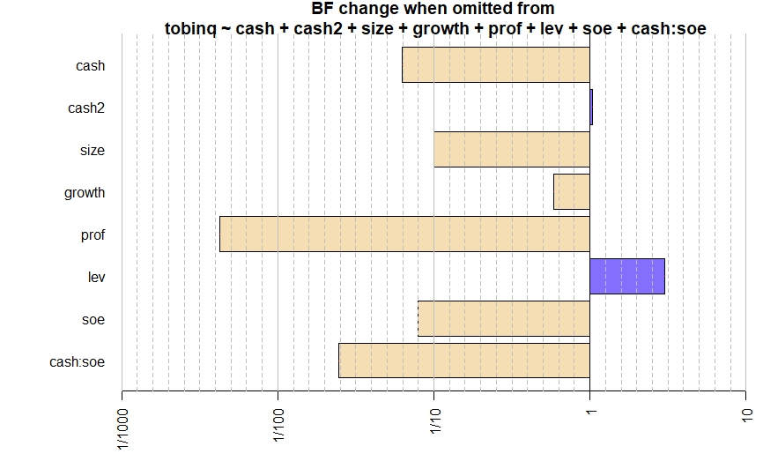
Figure 2: Change in Bayes Factor when omitted variables from most complex model
However, according to the result of comparing the highest score model to 4 following models in Table 3, model 2 is almost the same with the highest, but model 4 is only more than a half score to the highest. So, model 4 is dropped, only model 2 is qualified to the next step of drawing posterior distributions for parameters. The results from Table 4 of represent the posterior distribution for parameters of model 2. The mean of posterior distribution could be considered as the coefficient of the parameters in Frequentist approach.
Table 3: Compare the highest score model to 4 following models
No. | Model | Bayes Factor Compare Score
1 | cash + size + growth + prof + soe + cash:soe | 1 | ±0%
2 | cash + cash2 + size + growth + prof + soe + cash:soe | 0.918 | ±0%
3 | cash + size + prof + soe + cash:soe | 0.813 | ±0.01%
4 | cash + cash2 + size + prof + soe + cash:soe | 0.556 | ±0%
5 | size + prof | 0.379 | ±0%
Source: Authors calculate by compare function of BayesFactor package in R
With 95% credible interval, if the sign of parameters does not change in this interval, it could be understood as statistically confidence. In general, for key variables which are cash and cash2, the means are around 5.4 and -9.2 for respectively. The coefficients are 0.23 and -1.64 for state ownership and the interaction term cash:soe respectively. Other control variables such as size, growth, and prof have coefficient at around 0.076, 0.014, and 0.74 respectively. Except for cash2 and growth, all other variables have consistent signs in 95% incredible interval (from 2.5% to 97.5%) which mean there are no change in sign of coefficients in 95% incredible interval. Cash2 has credible interval from -21.62 to 3.41 and prof has incredible interval from -0.0066 to 0.03.
Table 4: MCMC results of posterior distribution for parameters
Variable | Mean | 95% Credible Interval
 |  | 2.5% | 97.5%
cash | 5.4149 | 1.4550 | 9.2945
cash2 | -9.1978 | -21.6200 | 3.4187
size | 0.0762 | 0.0193 | 0.1323
growth | 0.0147 | -0.0066 | 0.0304
prof | 0.7455 | 0.3497 | 1.1414
soe | 0.2314 | 0.0627 | 0.3989
soe:cash | -1.6439 | -2.6760 | -0.6243
Source: Authors calculate by posterior function of BayesFactor package in R
Figure 3 shows the trace and density plot for variables in model 2, the trace through ten thousand MCMC steps for all variables are almost consistent which indicate the validity of the density results. Also, as shown in Figure 3, prof only has a very small fraction of distribution falls below zero, and most of posterior distribution for cash2 is negative.

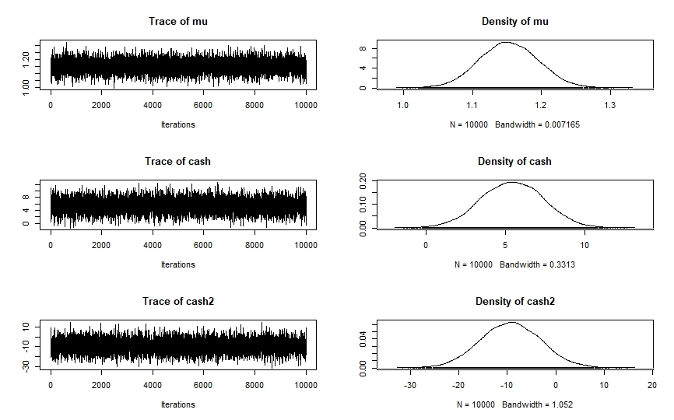

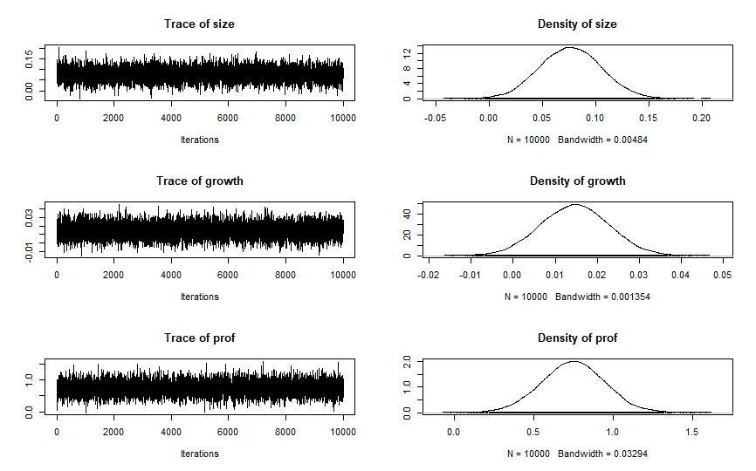

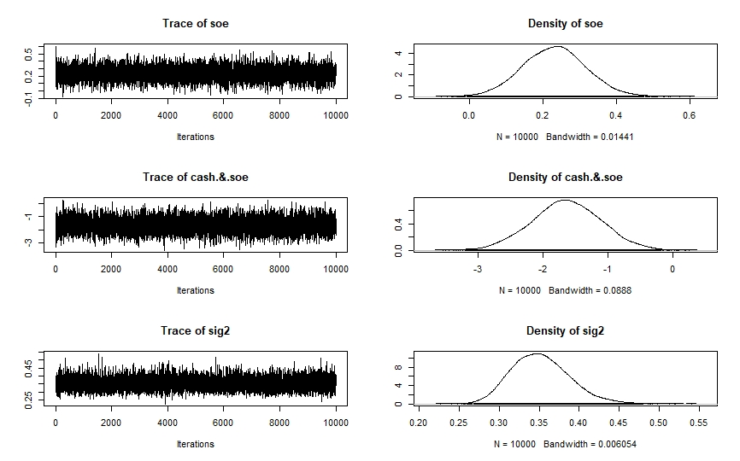

Figure 3: Trace and Density plot of posterior distribution for parameters
DISCUSSION & CONCLUSIONS
This study examines the effect of state ownership level on the relationship between cash holding ratio and firm’s value of 39 companies in Retail and Food & Beverage industries which are listed on Ho Chi Minh and Hanoi stock exchange market applying Bayesian approach. The test results illustrate that most variables have positive relationship with firm’s value.
In that, with a positive mean and consistent positive incredible interval, cash has a positive effect on firm’s value, indicating that cash generally creates value. Besides, the cash square has negative effect on firm’s value which possibly confirm the inverted U-shape relationship between cash and firm’s value. However, the inconsistent in sign across incredible interval of cash square indicated that there is a possible change in the sign of the coefficient and then the U-shape relationship is not completely supported. But as the majority of cash square posterior density fall below zero, it’s very likely that the cash square coefficient is negative. This is also an advantage of Bayes approach when provide a distribution of parameter’s coefficient instead of point estimation.
All control variables (size, growth, and profitability) have positive effects on firm’s value, especially profitability. Growth variable has negative value at 2.5% quantile, but only a very small fraction of the incredible interval falls below zero. So, the positive relationship between growth and firm’s value could be considered valid. Size and profitability also show a strong positive relationship with firm’s value. This is reasonable as strong firms with high profitability and opportunities to growth often have higher values.
State ownership variable has positive relationship with firm’s value. This result is contrary to some previous studies which suggest that enterprises with high state ownership often have low corporate value. However, after most state-owned enterprises in Vietnam have been equitized, the government only hold a small number of shares if the firm’s operation is good or if the firms are operating in important sectors of the economy (which the government need to take control). Therefore, the results of this study reflect that specifically in Vietnam, the enterprises with state ownership are highly valued.
The interaction term between state ownership and cash has an inverse relationship to the value of the enterprise. This result shows that the positive cash-firm’s value relationship is reduced slightly by state ownership. This led to the conclusion that the cash could contribute more to the firm’s value in firms with lower state ownership and vice versa. From these results, this paper recommends that firms with low state ownership could consider increasing the cash holding ratio to maximize the positive effect of cash into firm value. In contrast, firms with high state ownership must consider reducing the cash holding ratio and focus on reduce the conflict between shareholders and manages in cash management.
This study only focused on the effect of state ownership on the relationship between cash holding and firm’s value using Bayesian approach. Further research might explore in more detail the relationship between cash and firm value in different context such as market condition, industry competition, R&D intensity, corporate governance… Besides, some new approaches like machine learning, deep learning… could provide different points of view in this topic. The sample in this study was only Retail and Food & Beverage industries, further study on this subject could expand the sample size into different sectors or the whole Vietnam market as well.

List of abbreviations used
Abbreviation | Full meaning
tobinq | Tobin's Q score for firms
cash | Cash holding ratio variable in the model
cash2 | Square of Cash holding ratio variable in the model
soe | State Ownership variable in the model
cash:soe | Interaction term between cash and state ownership in the model
prof | Profitability variable in the model
size | Size variable in the model
growth | Growth variable in the model
lev | Leverage ratio in the model

The authors declare that they have no competing interests
REFERENCES
1. Harford J. Corporate cash reserves and acquisitions. The Journal of Finance. 1999;54(6):1969-97.
2. Jensen MC. Agency costs of free cash flow, corporate finance, and takeovers. The American economic review. 1986;76(2):323-9.
3. Myers SC, Majluf NS. Corporate financing and investment decisions when firms have information that investors do not have. Journal of financial economics. 1984;13(2):187-221.
4. Opler T, Pinkowitz L, Stulz R, Williamson R. The determinants and implications of corporate cash holdings. Journal of financial economics. 1999;52(1):3-46.
5. Keynes MJ. The general theory of employment interest and money. The Quarterly Journal of Economics. 1936;51(1):147-67.
6. Miller MH, Orr D. A Model of the Demand for Money by Firms. The Quarterly journal of economics. 1966;80(3):413-35.
7. Lee E, Powell R. Excess cash holdings and shareholder value. Accounting Finance. 2011;51(2):549-74.
8. Saddour K. The determinants and the value of cash holdings: Evidence from French firms. 2006.
9. Harford J, Mansi SA, Maxwell WF. Corporate governance and firm cash holdings in the US. Journal of financial economics. 2008;87(3):535-55.
10. Hafzalla N, Lundholm R, Matthew Van Winkle E. Percent accruals. The Accounting Review. 2011;86(1):209-36.
11. Martínez-Sola C, García-Teruel PJ, Martínez-Solano P. Corporate cash holding and firm value. Applied Economics. 2013;45(2):161-70.
12. Ha P. Cash holding, state ownership and firm value: The case of Vietnam. International Journal of Economics Financial Issues. 2016;6(6S):110-4.
13. Shinada N. Firms' Cash Holdings and Performance: Evidence from Japanese Corporate Finance. Research Institute of Economy, Trade and Industry (RIETI); 2012.
14. Thomsen S, Pedersen T. Ownership structure and economic performance in the largest European companies. Strategic Management Journal. 2000;21(6):689-705.
15. Shleifer A. State versus private ownership. Journal of economic perspectives. 1998;12(4):133-50.
16. Megginson WL, Nash RC, Van Randenborgh M. The financial and operating performance of newly privatized firms: An international empirical analysis. The Journal of Finance. 1994;49(2):403-52.
17. Yu M. State ownership and firm performance: Empirical evidence from Chinese listed companies. China Journal of Accounting Research. 2013;6(2):75-87.
18. Sun Q, Tong WH, Tong J. How does government ownership affect firm performance? Evidence from China’s privatization experience. Journal of Business Finance Accounting. 2002;29(1‐2):1-27.
19. Le TV, Buck T. State ownership and listed firm performance: a universally negative governance relationship? Journal of Management Governance. 2011;15(2):227-48.
20. Megginson WL, Ullah B, Wei Z. State ownership, soft-budget constraints, and cash holdings: Evidence from China’s privatized firms. Journal of Banking Finance. 2014;48:276-91.
21. Lewellen WG, Badrinath SG. On the measurement of Tobin's q. Journal of financial economics. 1997;44(1):77-122.
22. Lin C, Su D. Industrial diversification, partial privatization and firm valuation: Evidence from publicly listed firms in China. Journal of Corporate Finance. 2008;14(4):405-17.
23. McConnell JJ, Servaes H, Lins KV. Changes in insider ownership and changes in the market value of the firm. Journal of Corporate Finance. 2008;14(2):92-106.
24. Tong Z. Deviations from optimal CEO ownership and firm value. Journal of Banking Finance. 2008;32(11):2462-70.
25. Morck R, Shleifer A, Vishny RW. Management ownership and market valuation: An empirical analysis. Journal of financial economics. 1988;20:293-315.
26. McConnell JJ, Servaes H. Additional evidence on equity ownership and corporate value. Journal of Financial economics. 1990;27(2):595-612.
27. Package ‘bayesfactor’ [Internet]. 2015. Available from: http://cran/r-projectorg/web/packages/BayesFactor/BayesFactor.

